# Error log chapter 3

# 

# Exercise 4 error log

# No errors

Exercise 7 error log

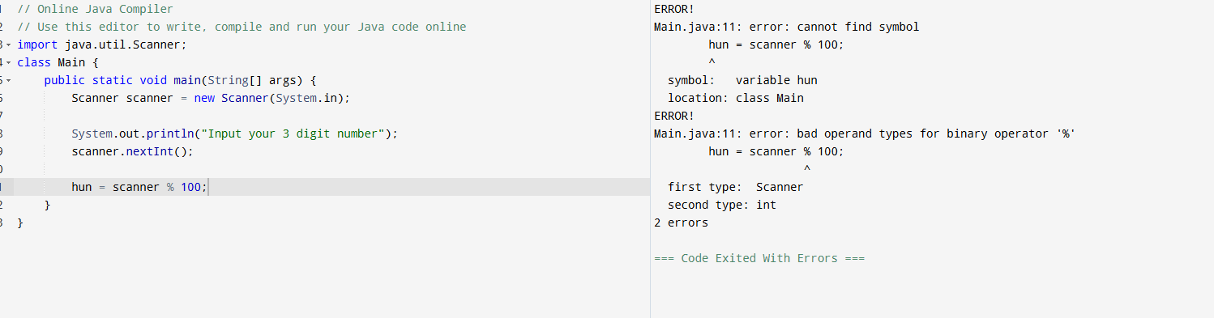

My scanner.nextInt(); doesn’t have a variable defining it and also my variable “hun” has no defined data type making error messages happen every time I run it

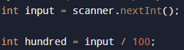

Input put as scanner’s variable and int was put in front of my “hundred” variable